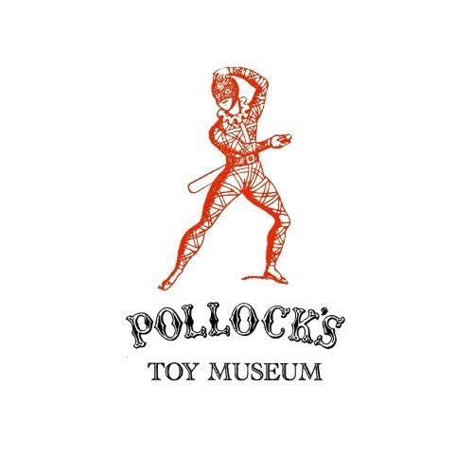

**School Booking Form**

**About your School**

|  |  |
| --- | --- |
| Name of main school contact |  |
| Email address of lead teacher |  |
| Name of school or college |  |
| School address |  |
| School phone number |  |
| School type (international, independent, SEN, State, other?) |  |
| What are your desired learning objectives for this session? |  |

**About your Booking**

|  |  |
| --- | --- |
| Year group attending |  |
| Number of students |  |
| Number of accompanying adults |  |
| Type of booking, please choose | **Pollock’s Toy Museum comes to the School:** 45 minuteworkshop leader visits your school with a range of toys (that are relevant to your studies) for pupils to handle and discuss plus a talk. Up to 3 workshops in a day (£240)  **Educational visit to Pollock’s Toy Museum Croydon**  To be held at Pollock’s Toy Museum Croydon in the Whitgift Centre. £240 for one session of up to 30 primary school children (accompanied by adults on a 1:4 ratio). Session lasts 1 hour. (Please note toilets are available in the shopping centre but not in the museum unit.) |
| Preferred date range for visit/trip (please provide a few options in order of preference) |  |
| Do any students have specific requirements or accessibility needs? |  |
| Any other notes or requirements? |  |

**Finances**

|  |  |
| --- | --- |
| Head of finance name |  |
| Head of finance email |  |
| Is the billing address the same as the school address? |  |
| If no, please include |  |
| Payment method (bank transfer, cheque, cash) |  |

**To be filled out by Pollock’s Education Team:**

|  |  |
| --- | --- |
| Notes/variations on booking |  |
| Date invoice sent |  |
| Date payment received |  |
| Method and date of payment |  |